AllWays: Accessible Group Travel Planner by Make Things Work
Team: Tan Yik Yang, Pat Yoon Xin, Lim Pei En, Jasmine Chin Jia Yee
Problem Statement: Travel Planner
Video Presentation: https://youtu.be/3VEqc3Pg-Dg
Presentation Slides: https://canva.link/kxj3nuiawmub8sa
Prototype Link: https://all-ways-two.vercel.app/

1. Project Overview

1.1 What the project is about:

AllWays is an inclusive, AI-powered group travel ecosystem that seamlessly synchronizes itineraries, manages shared finances, and ensures real-time safety. Unlike traditional travel apps, AllWays treats physical accessibility and user fatigue as non-negotiable baseline constraints, dynamically adjusting plans so every member of a group can travel comfortably.

1.2 Background & Context (The Problem):

Planning group trips typically requires juggling multiple fragmented apps for bookings, budgets, and itineraries, which causes immense stress when unexpected delays occur. This friction is exponentially worse for groups traveling with elderly members or individuals with disabilities. Existing market solutions completely ignore hidden constraints like stamina limits or the need for step-free routes. Consequently, coordinating accessible paths, tracking group fatigue, or finding safe regrouping points mid-trip becomes a logistical nightmare that current platforms fail to solve.

1.3 Core Project Features:

Fatigue & Accessibility-Aware Routing: AI generates optimized itineraries that automatically integrate rest stops, map step-free paths, and adjust travel pacing based on the group's predefined physical limits.

Real-Time Safety Sync & Smart Regrouping: Live GPS tracking monitors group proximity and dynamically suggests accessible, step-free meeting points if members separate or fall behind. For solo travelers, the Smart Route-Deviation Check monitors their planned route and detects unexpected deviations, prompting a discreet safety check and alerting emergency contact when necessary.

Smart Debt Optimization: A contextual expense ledger automatically calculates complex multi-person splits and generates precise debt settlements with one-tap payment reminders.
- Real Time Alternative Plan Generation: Adapts itineraries in real time to keep schedules flexible and feasible when unexpected delays, accessibility failures, safety risks, or closures occur.

Dynamic SOS & Ground Truth Logging: Provides accessibility-aware emergency routing and empowers users to contribute post-trip validation of real-world accessibility infrastructure.

1.4 Key Technologies:

Developed as an Android application using React Native, the platform leverages a Python (FastAPI) backend to orchestrate complex route optimization via the OpenAI API. Supabase powers real-time PostgreSQL WebSockets for live group tracking and collaborative voting, while the Google Maps Platform handles geographical validation.

2. Ideation & Process

2.1 Ideas We Considered
Idea | Explanation | Why it was dropped / kept
User Create Trip & Accessibility Profile (Chosen) | Users set up a plan with destination and travel dates, invite collaborators, and allow each member to define soft comfort preferences (e.g., travel style, desired places) alongside non-negotiable hard constraints (e.g., budget, dietary needs, wheelchair/step-free access, rest frequency). | This idea is essential to let users fill in their preferences and hard constraints (especially those elderly or disabled people who need easy accessibility).
System Build Group Profile (Chosen) | The system processes group inputs by treating accessibility needs as strict hard constraints while identifying overlapping interests and conflicting preferences among members. | This idea is essential to find out group members’ common preferences.
Accessibility & Feasibility Validation (Chosen) | The system validates candidate places and routes against the group's hard accessibility requirements, automatically eliminates infeasible options, and flags unverified accessibility data. | This idea is essential to eliminate the choices that are unsuitable for users.
AI Generates Feasible Itinerary (Chosen) | AI ranks validated options, clusters nearby places, and optimizes routes to create an optimized day-by-day travel plan. | This idea is essential to provide an efficient route for users.
Group Review & Voting & Adjustment (Chosen) | Group members review the generated plan to vote, swap, or remove activities, while the system offers compliant alternative recommendations whenever changes are made. | This idea is essential to provide flexibility for users.
Agent Searches & Prepares Bookings (Chosen) | AI agents compare travel options (flights, hotels, transport, attractions) via APIs, pre-fill booking details on external sites to reduce manual errors, and present direct booking links for users to check and make payment. | This idea is essential to save users’ time from comparing a variety of options. Presenting direct booking links and pre-filling booking details help reduce manual errors.
System Set Individual Trip Budget (Chosen) | The system stores individual user budgets, compares them against estimated itinerary costs, and automatically reserves portions of the budget for leisure, shopping, and contingency funds. | This idea is essential to ensure users are always on budget.
Personal Expense Tracking using Receipt Scanning (Chosen) | Individual spending is tracked either automatically through digital receipts detected from emails or via manual entry, which dynamically updates the user's remaining personal budget. | This idea is essential to track users’ spending in real time, making the budget estimation correct.
Record Shared Expense & Debt Settlement (Chosen) | Users can upload receipts for shared costs, select which group members consumed specific items, and let the system calculate tax and tip to generate precise debt settlements. | This idea is essential to solve group trips’ paint point: splitting cost.
Predictive Budget Guard & Budget Rescue (Chosen) | The system projects total trip costs, alerts users if they risk overspending their individual limits, and offers an automated itinerary replan. | This idea is essential to predict and take actions before the budget really runs out.
Real Time Reminder Engine (Chosen) | System generates real-time notifications for scheduled activities, departure times, booking and ticket details, required rest breaks, and specific accessibility alerts. | This idea is essential to remind users and prevent them from running late.
Real Time Trip Progress Tracking (Chosen) | System tracks user locations in real time to automatically recalculate arrival and leave-by times when delays occur, while allowing travelers to manually extend stay durations (e.g., +15, 30, or 45 mins) or adjust plans on the fly. | This idea is essential to maintain a flexible itinerary for users.
Real Time Map Direction (Chosen) | System integrates with map APIs to guide users’ direction in real time. | This idea is essential to prevent users from getting lost.
Real Time Alternative Plan Generation (Chosen) | Case 1: Accessibility Disruption  - System detects when a route or venue fails hard accessibility requirements (e.g., broken elevator or blocked step-free path),, and immediately reroutes.  Case 2: Safety Disruption  - System identifies conflicts with safety parameters (such as late-night walking distances after cutoff hours) and suggests safer options.  Case 3: Unexpected Event (Bad Weather / Attraction Closure / User Running Late)  - System detects when weather is bad / attraction is close / user is running late, and offers quick fixes in real time | This idea is essential to ensure the itinerary is always feasible although unexpected events happen.
Location Sharing (Chosen) | Users can choose to share real-time locations with emergency contacts for supervision and helps identify separated group members by suggesting accessible meeting points and routes. | This idea is essential to keep users safe by tracking users’ real time location.
Group Proximity Tracker (Chosen) | System detects when a group member wanders off unexpectedly, sends a discreet check-in notification, prompts other members for updates, and broadcasts live GPS coordinates to emergency contacts if unresponsive or flagged as lost. | This idea is essential to ensure users’ safety and take action if users are at risk of being involved in local crimes, such as phone snatching or kidnapping.
Smart Route-Deviation Check (Chosen) | Monitors path compliance and sends a silent status prompt if a user completely deviates from the planned route; if unanswered or an incorrect PIN is entered under duress, it silently alerts emergency contacts. | This idea is essential to ensure users’ safety and take action if users are at risk of being involved in local crimes, such as phone snatching or kidnapping.
Emergency SOS Button (Chosen) | Instant-action button that immediately captures the user's latest GPS location and sends it to emergency contacts. | This idea is essential to help users keep in touch with helpers when an emergency happens.
Audio-Ambient Threat Detection (Dropped) | System listens specifically for distress signatures such as user screaming and automatically begins audio records. | This idea is dropped because audio detection APIs are not affordable at the current stage.
Language Translator (Dropped) | Translate dialogue in real time so users can easily seek help and converse smoothly with locals. | This idea is currently dropped because there are other similar apps that can do the same.
Trip Journal (Dropped) | Turn users’ planned itinerary into an interactive travel diary by logging stops, mapping routes, adding personal notes, and uploading photos | This idea is dropped as this feature is not a core requirement.
Solo Trip Proximity Tracker (Dropped) | User links to a Bluetooth wearable device (e.g., smartwatch) to detect sudden separations over 15 feet or dropped connections. | This idea is dropped because not everyone has wearable devices.

2.2 Ideation Boards

Mindmap Board Link: https://boardmix.com/app/share/CAE.CJa27wIgASoQ4uG1D6R72XAqxlZfLJA1vzAGQAE/dJYjho

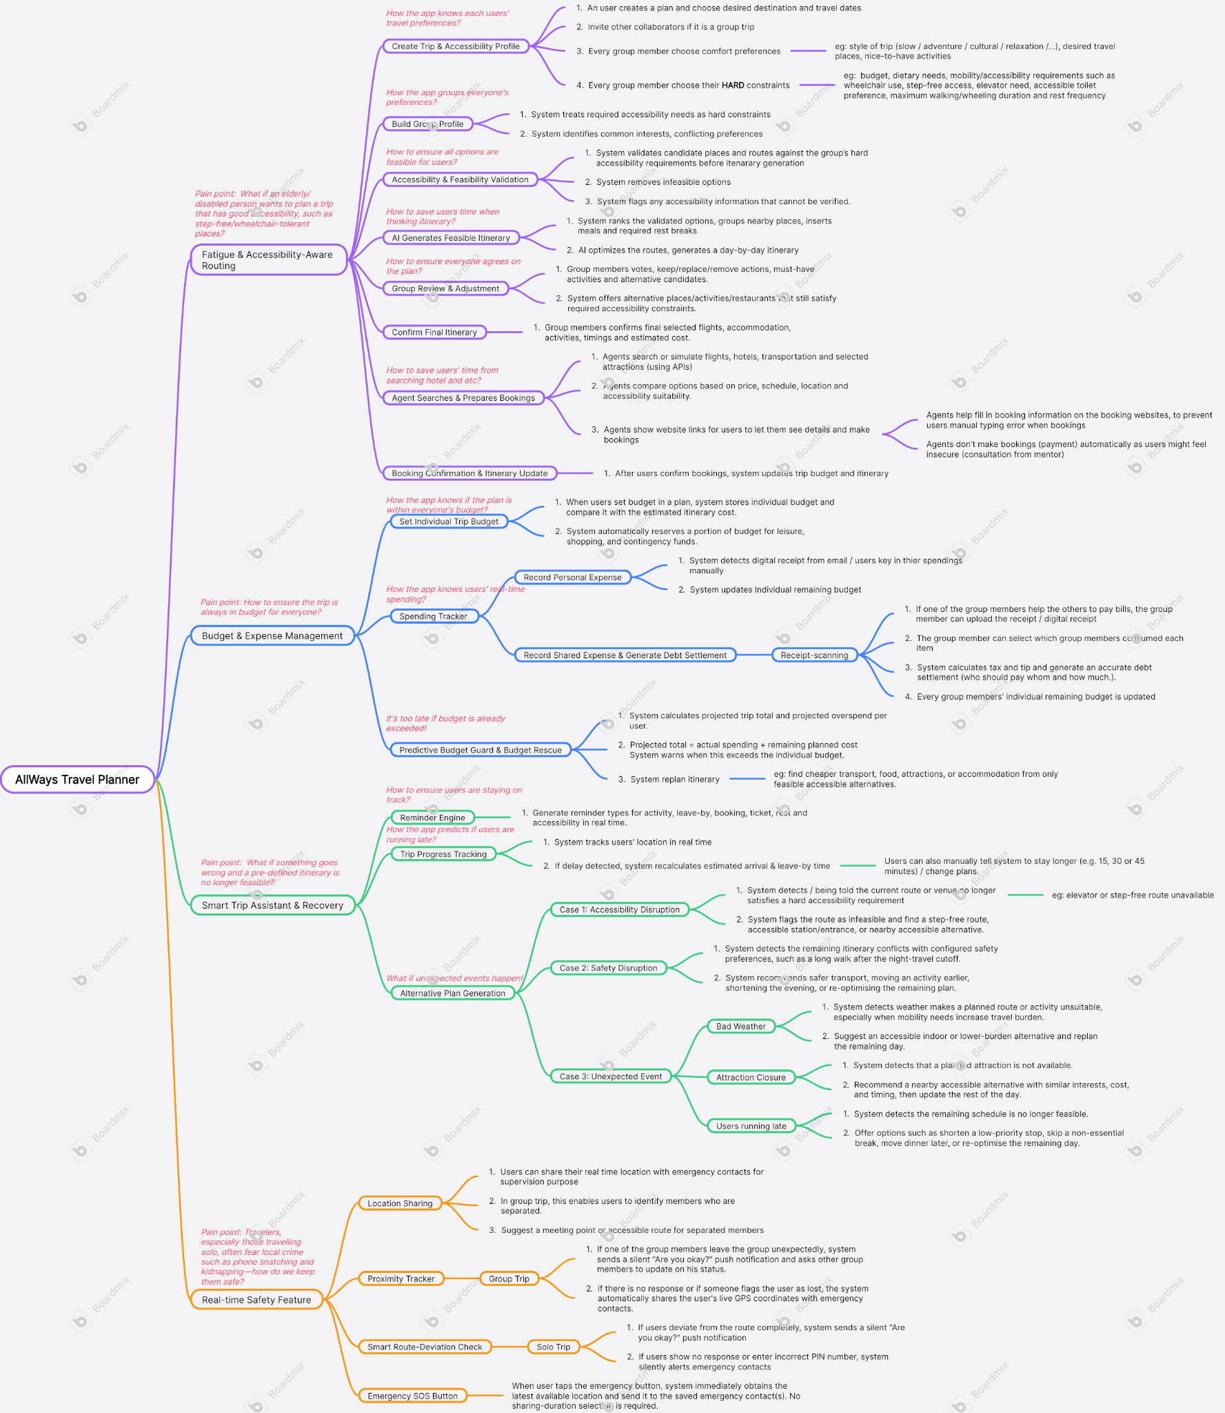

2.3 Mentor Consultation
Date | Mentor | Feedback Received | What Was Changed
3 Sep 2026 | Mr. Khor Jia Quan | The initial system proposed an AI agent that would directly perform accommodation bookings and payments. The mentor raised concerns that users may be reluctant to trust an AI system to make financial transactions on their behalf. | The booking agent functionality was removed based on the mentor's recommendation. The system was redesigned to provide AI-generated accommodation recommendations while allowing users to review the options and proceed to external booking platforms themselves. This gives users greater control and reduces concerns regarding AI making financial transactions.
3 Sep 2026 | Mr. Khor Jia Quan | The initial itinerary-generation process consisted of seven separate processes, which could result in a lengthy and complicated user journey. The mentor advised simplifying the process to improve usability. | The itinerary-generation workflow was redesigned based on the mentor's feedback. The original seven-step process was reduced to two main processes, allowing users to provide their requirements and generate an initial itinerary more efficiently while maintaining the key planning information required by the system.
3 Sep 2026 | Mr. Khor Jia Quan | The mentor suggested that incorporating accessibility into itinerary planning could provide a stronger and more meaningful direction for the application, particularly for travellers with mobility difficulties | Accessibility was incorporated as a core consideration in the itinerary-generation process. Users can now provide their accessibility requirements, which are considered when generating travel recommendations and itineraries. This shifted the system from general itinerary planning towards a more inclusive and user-centred travel planning solution.
11 Sep 2026 | Ms. Yeong Chiau Wen | The initial bill-splitting function required the participant who paid the bill to manually enter the amount payable by each participant. The mentor suggested using OCR to reduce manual data entry and make the process more convenient. | The bill-splitting workflow was enhanced by incorporating OCR-based receipt recognition. Instead of manually entering every item and amount, the system can extract items and prices from a receipt. The host can then assign the recognized items to the respective participants, allowing the system to calculate each person's share automatically.
11 Sep 2026 | Ms. Yeong Chiau Wen | The mentor highlighted that the proposed application's novelty may not be sufficiently clear through the demo part alone, especially when compared with existing travel-planning applications. | The presentation and demo strategy were revised in response to this feedback. A comparison between existing travel applications and the proposed system was added to explicitly demonstrate the application's unique combination of features and highlight how it addresses limitations that are not fully addressed by conventional travel-planning applications.
11 Sep 2026 | Ms. Yeong Chiau Wen | The mentor suggested that safety could be a strong differentiating aspect of the application and recommended giving greater emphasis to travellers' safety needs. | Safety was strengthened as one of the key focuses of the proposed system. Safety-related functions were given greater prominence in the system design and presentation, including features such as group location sharing and emergency location sharing. This feedback also influenced the positioning of the application as more than an itinerary planner by addressing travellers' safety needs throughout their trip.

3. Design & Prototype

4. What Makes It Different
List out novel features and explain briefly which each is original or what the twist is.
You can have a comparison table to compare with existing solutions named in section 1 but this is completely optional.

Novel Feature | The Twist / What Makes It Different | How It Works
Fatigue & Accessibility-Aware Routing | Traditional planners just plan where to go, but our app ensures that everyone, including elderly and disabled travelers, can reach their destinations comfortably. | AI generates optimized itineraries that automatically integrate rest stops, map step-free paths, and adjust travel pacing based on the group's predefined physical limits.
Group Accessibility Agreement | Helps the whole group agree on accessibility needs before the trip. | • Collaborative Voting: Members review the generated itinerary to vote, swap, or remove activities together.  • Smart Alternatives: Automatically suggests compliant alternative recommendations in real time whenever changes or removals are made to keep the trip feasible.
Alternative Plan Generation | Adapts itineraries in real time to keep schedules flexible and feasible when unexpected delays, accessibility failures, safety risks, or closures occur. | • Progress Tracking: Automatically recalculates arrival and leave-by times during delays, allowing manual stay extensions (+15, 30, or 45 mins).  • Accessibility Disruption: Instantly reroutes when a route or venue fails hard accessibility requirements like broken elevators.  • Safety & Event Disruption: Flags safety conflicts or unexpected events (bad weather, closures, running late) and offers instant alternative fixes.
Smart Budget & Expense Management | Integrates personal budgeting, automated receipt scanning, and smart group splitting into a single predictive system to prevent overspending. | • Individual Budget & Tracking: Stores personal budgets, reserves contingency funds, and updates remaining balances via email receipt scanning or manual entry.  • Group Cost Splitting: Automatically calculates item-specific splits, taxes, and tips for shared receipts.  • Predictive Guard & Rescue: Projects total costs and triggers an automated itinerary replan if you risk running out of funds.
Real-Time Safety & Separation Guard | Acts as a dual-layer safety net protecting groups from getting silently separated and safeguarding solo explorers against local crime risks like snatch thefts or kidnapping. | For Groups: Live GPS proximity tracking monitors distance; if a teammate wanders off, it triggers a discreet check-in, alerts the team, and suggests an accessible, step-free meeting point.  For Solo Travelers: Tracks path compliance in real-time. A deviation triggers a silent status check; if unanswered or a duress PIN is entered, emergency contacts receive live coordinates.  Emergency SOS: Instant-action button that captures the user's latest GPS location and current information, broadcasting it along with accessibility needs to emergency contacts and local enforcement.

Feature | AllWays | Wanderlog | TripIt Pro | Inspirock
Trip Planning & Itinerary Sync | Supported | Supported | Supported | Supported
Group Accessibility Agreement | Supported | Not Supported | Not Supported | Not Supported
Alternative Plan Generation | Supported | Not Supported | Not Supported | Not Supported
Smart Budget & Expense Management | Supported | Supported | Not Supported | Not Supported
Fatigue-Aware Trip Planning | Supported | Not Supported | Not Supported | Supported
Accessibility-Aware Routing | Supported | Not Supported | Not Supported | Not Supported
Live Group Separation / Proximity Tracking | Supported | Not Supported | Not Supported | Not Supported
Smart Route-Deviation Check | Supported | Not Supported | Not Supported | Not Supported
Accessibility-Aware SOS & Help | Supported | Not Supported | Not Supported | Not Supported

5. Technical Architecture & Feasibility

5.1 Tech Stack
Our technical choices are strictly driven by the project's heavy reliance on real-time group synchronization, mobile hardware integration (GPS sensors) and AI-driven data processing.

- Frontend: React Native
- Why we chose it: A mobile-first approach is mandatory for features like Real Time Trip Progress Tracking, Smart Route-Deviation Check, and the Emergency SOS Button. React Native allows us to build a cross-platform mobile application efficiently while accessing native device sensors.

- Constraints expected: Managing continuous background location permissions and persistent background tasks across diverse Android OS versions and manufacturer battery-saver restrictions will be a primary technical hurdle.

- Backend: Python (FastAPI)
- Why we chose it: Given our heavy reliance on AI for AI Generates Feasible Itinerary and identifying overlapping preferences in System Build Group Profile, Python is the industry standard for AI orchestration and data clustering. FastAPI is chosen because it is incredibly fast, lightweight, and natively supports asynchronous operations, making it perfect for handling concurrent third-party API calls without blocking the server.

- Constraints expected: Implementing real-time WebSocket connections in Python(FastAPI) can be slightly complex. Additionally, deploying Python backends on free-tier hosting services may result in slower "cold starts" after periods of inactivity.

- Database: Supabase (PostgreSQL)
- Why we chose it: Supabase provides out-of-the-box WebSocket subscriptions. This is critical for live collaboration features like Group Review & Voting & Adjustment and instantly updating calculations for Record Shared Expense & Debt Settlement.

- Constraints expected: As a free-tier service, we expect strict limits on concurrent connections and database read/write speeds when multiple groups are updating their states in real-time.

- APIs & Third-Party Services
- OpenAI API (GPT-4o): Used for AI Generates Feasible Itinerary and identifying conflicting preferences in System Build Group Profile. The AI will generate travel recommendations based on user preferences, accessibility requirements, budget, and available location information.
Constraint: API latency and hallucination risks; user preferences and relevant location data will be summarized before being sent to the API, and previously generated recommendations will be cached to avoid repeated requests. Smaller models will be used for simpler tasks, while GPT-4o will be reserved for complex itinerary generation.

- Google Maps Platform (Places & Routes API): Used to display maps, discover realworld places, and calculate routes for Accessibility & Feasibility Validation, Real Time Map Direction, and Smart Route-Deviation Check.
Constraint: High usage costs and strict rate limits; place and route results will be cached, autocomplete requests will be debounced, and routes will only be recalculated when the user's deviation exceeds a predefined threshold.

- Google Cloud Vision API: Chosen for OCR in Personal Expense Tracking using Receipt Scanning.
Constraint: Receipt images will be compressed and validated before OCR processing, and extracted results will be stored so that the same receipt does not need to be processed repeatedly.
- Expo Location & Expo Task Manager: Used to obtain the user's GPS location and support background location tracking for Real Time Trip Progress Tracking, Smart Route-Deviation Check, and Emergency SOS.
Constraint: Continuous high-frequency GPS tracking can increase battery consumption and backend requests; location updates will use appropriate time and distance intervals, with more frequent tracking enabled only during active trips. Minor location changes will be processed locally before being sent to the backend.
- Expo Notifications / Firebase Cloud Messaging (FCM): Used to send push notifications for trip reminders, group itinerary updates, route deviations, expense updates, and emergency alerts. Constraint: Notifications will only be triggered for meaningful events rather than frequent state changes to reduce unnecessary requests and notification overload.
- OpenStreetMap / Overpass API: Used as an additional source of accessibility-related information such as wheelchair-accessible entrances, elevators, ramps, stairs, and accessible facilities. Constraint: Accessibility data coverage and accuracy depend on community-contributed map data; retrieved accessibility information will be cached to reduce repeated external requests and improve response times.
- Supabase Auth: Used for user registration, authentication, session management, and protecting access to personal trips, expenses, and location-sharing features. Constraint: Authenticated sessions will be maintained efficiently, and only the data required by each screen will be retrieved to reduce unnecessary database requests.

- Hosting
- Frontend: Expo Application Services (EAS) for rapid cloud building and easy Android deployment to generate shareable APKs for testing without heavy local native setups. Builds will be generated only when necessary during development.
- Backend & APIs: Render for deploying Python and FastAPI services quickly while managing AI API environment variables securely. API requests will be handled asynchronously and unnecessary background processes will be avoided to reduce resource consumption.
- Database: Supabase Cloud for hosted PostgreSQL, authentication, real-time subscriptions, and receipt/image storage. Database queries will be optimized and only required fields will be retrieved to reduce unnecessary database usage and improve response times.

5.2 Build Plan & Scope (MVP Realism)
To achieve maximum technical viability within the hackathon timeframe, we have structured a strict Minimum Viable Product (MVP) scope. While all 19 "Chosen" ideas form our core product roadmap, we will prioritize features that prove our core logic, while mocking hardware-dependent or computationally expensive features to remain realistic regarding time and resource limits.

Phase 1: What we will build (Fully Functional)

- Profile & AI Logic: User Create Trip & Accessibility Profile and System Build Group Profile. We will implement the exact logic that treats accessibility as a hard constraint.

- Core AI Routing: AI Generates Feasible Itinerary and the Group Review & Voting & Adjustment system utilizing Supabase real-time sync.

- Budgeting Foundation: System Set Individual Trip Budget and Record Shared Expense & Debt Settlement (calculating tax/tips for the group).

- Safety Essentials: The Emergency SOS Button (capturing live GPS) and Real Time Map Direction.

Phase 2: What we will SIMULATE or MOCK (To respect time & API constraints)

- Agent Searches & Prepares Bookings: Live flight/hotel booking APIs are highly restricted. We will mock the API responses to demonstrate the UI of pre-filling booking details and presenting direct links.

- Personal Expense Tracking using Receipt Scanning: We will build the manual entry flow to ensure the Predictive Budget Guard works, but the actual OCR scanning execution will be mocked with pre-processed receipt data.

- Real Time Alternative Plan Generation: We will hardcode specific trigger scenarios (e.g., clicking a "Simulate Bad Weather" button) to demonstrate how the system immediately reroutes, rather than constantly polling live weather/traffic APIs.

